α

The Alpha Software Development Team

System Analysis Document

Prepared for: Sergeant Patrice Poitevin

Prepared By:

Hussain Farbotko-Merabaksh, Project Leader,

Nicolas Castilloux,

Curtis Collins,

Anthony Guevara,

Patrick Ings,

Brian Reed

Table of Contents

1 Information Description 1

1.1 Entity Relationship Diagrams (ERDs) 1

1.1.1 System ERD 2

1.1.2 Entries ERD 3

1.1.3 Contributors ERD 4

1.1.4 Organizations 5

1.1.5 Member Type 6

1.1.6 Zone ERD 6

1.1.7 Messages ERD 7

1.1.8 Drug Info ERD 8

2 Functional Description 9

2.1 Overview of the system 9

2.2 Context Diagrams 10

2.3 Data Flow Diagram – Level 1 11

2.4 Data Flow Diagram – Level 2 12

2.5 High Level Use Case Diagram 16

2.5.1 Reports Use Case Diagram 17

2.5.2 Entries Use Case Diagram 17

2.5.3 Administration Use Case 18

2.5.4 Messaging Use Case Diagram 18

2.5.5 Contributors Use Case Diagram 19

2.5.6 Zone Use Case Diagram 19

3 Behavioural Description 20

3.1 Reports 20

3.1.1 Generate Report 20

3.1.2 Generate Pre-Selected Report 21

3.2 Entries 22

3.2.1 View Listings 22

3.2.2 Search Entries 23

3.2.3 New Entry 24

3.2.4 Edit Entry 25

3.2.5 View Report 26

3.2.6 View Entry 27

3.3 Administration 28

3.3.1 View Table 28

3.3.2 Add Descriptor 29

3.3.3 Delete Descriptor 30

3.4 Messaging 31

3.4.1 View Messages 31

3.4.2 Read Message 32

3.4.3 Reply to Message 33

3.4.4 New Message 34

3.4.5 Receives Message 35

3.5 Contributors 36

3.5.1 View Contributors 36

3.5.2 Search Contributors 37

3.5.3 View Contributor 38

3.5.4 View Organization 38

3.5.5 Edit Organization 39

3.6 Zone 40

3.6.1 View Zone 40

3.6.2 Generate Preselected Report 41

3.7 Appendix A – Data Dictionary 41

3.7.1 Administrator Drugs: 41

3.7.2 Contributor’s Page 42

3.7.3 Organization’s Page 42

3.7.4 Message Page 43

3.7.5 Entries 43

3.8 Appendix B – List of Acronyms 43

# Contact Information

Sgt. Patrice Poitevin

Royal Canadian Mounted Police

Drugs and Organized Crime Awareness

Phone:(613) 296 9638

[Pat.poitevin@rcmp-grc.gc.ca](mailto:Pat.poitevin@rcmp-grc.gc.ca)

## Core

### Project Team Leader:

Hussain Farbotko Merabaksh

[hmerabaksh@gmail.com](mailto:hmerabaksh@gmail.com)

Project Leader

### Project Group Members

|  |  |
| --- | --- |
| Nicolas Castilloux  [nick.castilloux@gmail.com](mailto:nick.castilloux@gmail.com) | Curtis Collins  [wcurtiscollins@gmail.com](mailto:wcurtiscollins@gmail.com) |
| Anthony Guevara  [anthony.guev@gmail.com](mailto:anthony.guev@gmail.com) | Patrick Ings  [PatrickIngsJr@gmail.com](mailto:PatrickIngsJr@gmail.com) |
| Brian Reed  [brianreed23@gmail.com](mailto:brianreed23@gmail.com) |  |

### Project Professor And Project Advisor:

Mr. Edmund G. Strange

Algonquin College – Woodroffe Campus

Computer Studies Department

1385 Woodroffe Avenue

Ottawa, Ontario

K2G 1V8

Phone:(613)727-4723 ext 3483

strange@algonquincollege.com

# Information Description

The Drug Trend Tracking and Mapping Solution is a software solution designed to gain anecdotal data on the use of drugs in the city. The first iteration provided by Riftpoint development. The initial iteration provides the ground works for the application, it including functionality for users, entries, reports, messaging and the ability to add or delete drug types and various information on drugs. The purpose of this iteration is to provide additional functionality, mainly in the UI, but in the data sections, the system needs to ability to add information relevant to information on drugs.

## Entity Relationship Diagrams (ERDs)

This section contains Entity Relationship Diagrams showing the relationship between the entities in the system, these entities are the Contributors, Zones, Drug Info and Entries. It also contains a high level view of the Database’s entities.

### System ERD



Figure 1. System ERD

This system shall have entries that, an individual entry shall contain a zone and contributor and some information on the properties of the drug reported. Each contributor may have zero or more entries and will be associated with one zone.

### Entries ERD



Figure 2 Entries ERD

An Entry must contains a date of the event, the date the data was entered, a Contributor, a zone, a gender of the reported, an age and related information on the drug taken. All of these items may or may not be associated with 1 or more entries. Information on Contributors can be found in section [SECTION NUMBER], Zone can be found in section [SECTION NUMBER], and Drug Info can be found in [SECTION NUMBER].

### Contributors ERD



Figure 3 Contributor ERD

A contributor has the following mandatory attributes: full name, email address, member since, organization, member type, zone, and number of entries. It can also include the last login date, but this may not exist in some circumstances. Information on zones can be found in [SECTION NUMBER], member type can be found in 2.1.5, organization can be found in 2.1.4.

### Organizations

Figure 4 Organization

An organization contains an organization name, an organization URL and an organization address that is unique to it. A contributor contains one organization, but an organization contains 0 or more contributors. Information on Contributor can be found in section 2.1.3.

### Member Type



Figure 5 Member Type

A member type contains a member organization name that is unique to it. A contributor contains one member type, but an organization contains 0 or more contributors. Information on Contributor can be found in section 2.1.3.

### Zone ERD



Figure 6 ZONE ERD

The Zone entity contains information on its geographic location and its name. A zone contains zero or more entries and contributors. More information on Contributors can be found in section 2.1.3 and Entries can be found in section 2.1.2.

### Messages ERD



Figure 7 Messaging ERD

Messages are stored in the inbox. Messages contain a mandatory message text, time sent, sender, and receiver. Messages also contain an optional attribute stating whether or not the message has been read.

### Drug Info ERD



Figure 8

The administrator info contains the drug information that can be used in an entry. The info categories that an administrator can add and delete from are drug type, drug name, drug street name, drug form, drug colour, pill stamp, pill shape, side effect, and organization. Each category may contain zero or more entries.

# Functional Description

The system is split into 6 separate modules, the entries module, the reporting module, the contributor’s module, the admin module, the zone and the message module.

## Overview of the system



Figure 9 Decomposition diagram

## Context Diagrams



Figure 10 Context Diagram

The system allows contributors and administrators to create entries and request reports, as well as message users. The system will send messages to the appropriate user or administrator. The administrators can edit the drug information and contributor information. Administrators also function as regular contributors.

## Data Flow Diagram – Level 1



Figure 11 Level 2 DFD

Users perform data operations on multiple data stores. They Create, edit, and view entries, as well as view other contributors and organizations. They are able to send and receive messages, and through entries are able to view different drug information. Administrators are able to create and delete both drug information and contributors.

## Data Flow Diagram – Level 2

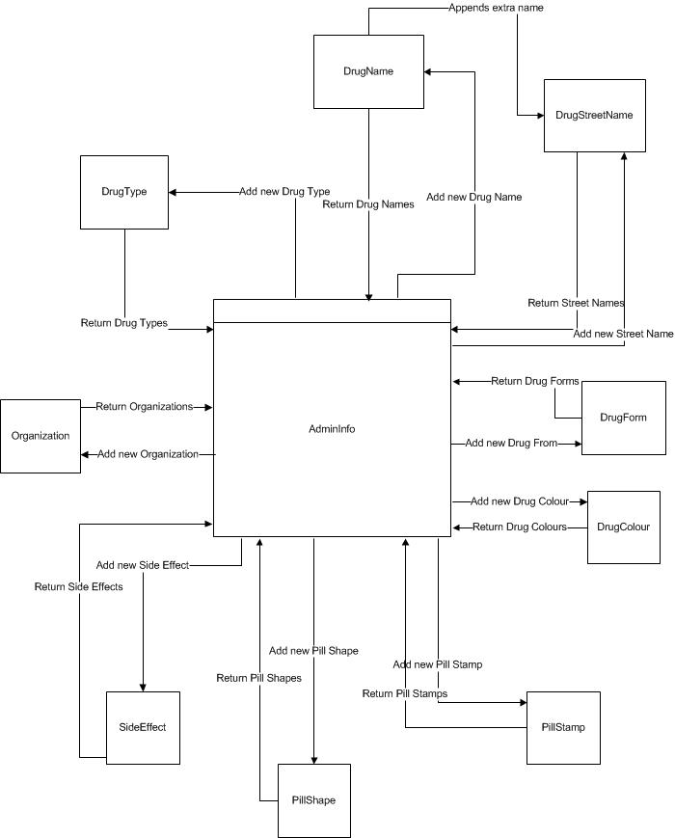

Figure 12 Data Flow Diagram for Administrators

Administrators are able to create and delete drug information as well as organizations. The drug information maintained by the administrators can be used by contributors when creating drug information entries.

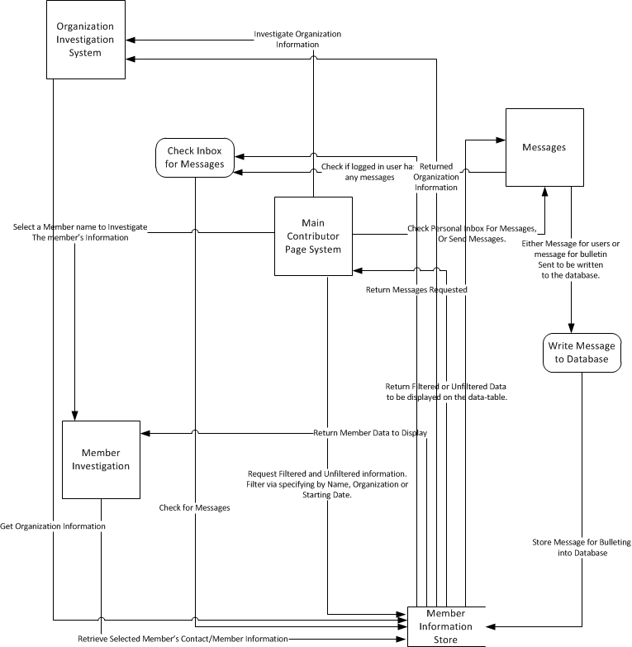

Figure 13 Data Flow Diagram for Contributors

A contributor is able to view information on all other contributors. Regular contributors can view personal information, organizational information, date of registration, and are also able to send messages to other contributors. Administrators are able to edit all information belonging to a contributor.

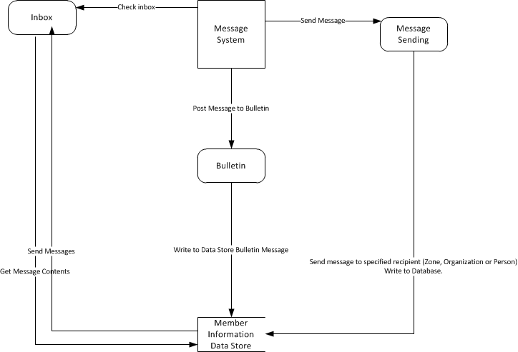

Figure 14 DFD for Messages

Messages can be sent from a contributor (administrator being a contributor) to another contributor. The messages are stored in the system. Each contributor his an inbox which is used to retrieve messages received from another contributor.

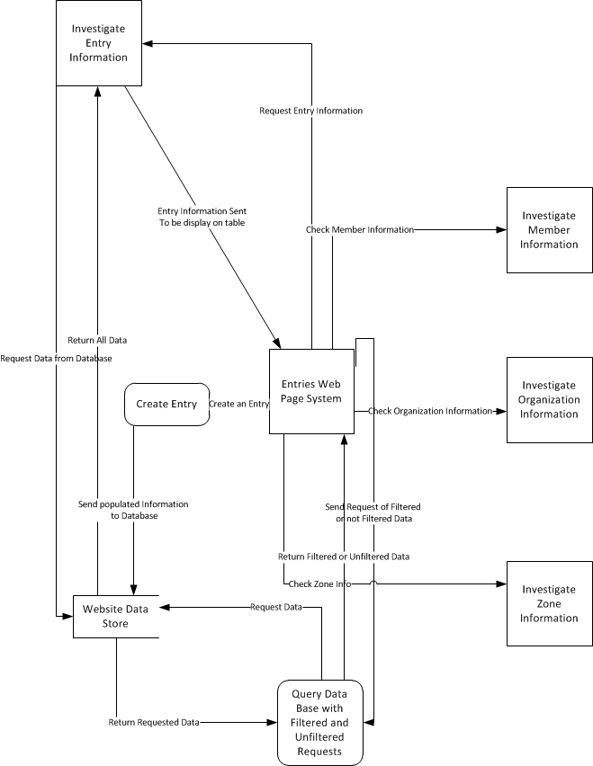

Figure 15 DFD for Entries

Contributors are able to submit drug information entries that can be viewed by other users. Each entry is associated with a contributor, a zone, and relevant drug information. Contributors are also able to view submitted entries, and filter them based on the information inside. Entries may also be edited by a contributor.

## High Level Use Case Diagram



Figure 16 High Level Use Case Diagram

### Reports Use Case Diagram



Figure 17 Reports Use Case

### Entries Use Case Diagram



Figure 18 Entries Use Case Diagram

### Administration Use Case



Figure 19 Administration Use Case

### Messaging Use Case Diagram



Figure 20 Messaging Use Case Diagram

### Contributors Use Case Diagram



Figure 21 Contributors Use Case Diagram

### Zone Use Case Diagram



Figure 22 Zone Use Case Diagram

# Behavioural Description

## Reports

### Generate Report



Figure 23 Generating a Report TSD

|  |  |  |
| --- | --- | --- |
| Use Case Number: | R1 | |
| Use Case Name: | Generating a Report | |
| Requirements Source: | Previous Team Iteration | |
| Supporting Diagrams: | Figure 17 | |
| Primary Actor/Entity: | User | |
| Description: | A user wants to generate a custom report | |
| Pre-Condition: | User must be logged in. | |
| Trigger: | User has selected Generate Custom Report Action | |
| Typical Course Of Events: | Actor Action: | Server Action: |
| User selects a type of report | Proceeds to the next dialog |
| User selects constraints | Proceed with to generate report |
|  | Report is generated and displayed tot the user |
| Conclusion: | A report is generated | |
| Business Rules: | BRR1. User must select a report type.  BRR2. User must select 1 comparison rule from the provided | |

### Generate Pre-Selected Report



Figure 24 Generating a pre-selected report TSD

|  |  |  |
| --- | --- | --- |
| Use Case Number: | R2 | |
| Use Case Name: | Generating a pre-selected report | |
| Requirements Source: | Previous Team Iteration | |
| Supporting Diagrams: | Figure 17 | |
| Primary Actor/Entity: | User | |
| Description: | A user wants to generate pre-selected report | |
| Pre-Condition: | User must be logged in. | |
| Trigger: | User has selected one of the per-selected reports | |
| Typical Course Of Events: | Actor Action: | Server Action: |
| User selects one of the pre-selected reports | Generates Report and displays it to the user |
| Conclusion: | A report is generated | |

## Entries

### View Listings



Figure 25 View Entries TSD

|  |  |  |
| --- | --- | --- |
| Use Case Number: | E1 | |
| Use Case Name: | View Entries | |
| Requirements Source: | Previous Team Iteration | |
| Supporting Diagrams: | Figure 2, Figure 18 | |
| Primary Actor/Entity: | User | |
| Description: | A user views the entries | |
| Pre-Condition: | User must be logged in. | |
| Trigger: | User clicks the Entries Page. | |
| Typical Course Of Events: | Actor Action: | Server Action: |
| User clicks the Entries Page. | Server displays a list of entries |
| Conclusion: | A list of entries is displayed to the user | |

### Search Entries



Figure 26 View Filtered list of entries TSD

|  |  |  |
| --- | --- | --- |
| Use Case Number: | E2 | |
| Use Case Name: | View filtered list of entries | |
| Requirements Source: | Previous Team Iteration | |
| Supporting Diagrams: | Figure 2, Figure 18 | |
| Primary Actor/Entity: | User | |
| Description: | A user wants a filtered list of entries. | |
| Pre-Condition: | User must be logged in and on the entries page. | |
| Trigger: | The user clicks the filter button | |
| Typical Course Of Events: | Actor Action: | Server Action: |
| User inputs how he wants his data filtered. | Server fetches a list of items with the giving filters |
|  | Server displays a list of filtered entries |
| Conclusion: | A list of filtered entries is displayed | |
| Business Rules: | BRE1. Use of wildcards is supported  BRE2. Date fields must be in the given format MM/DD/YYYY  BRE3. Date fields must provide a drop down list to facilitate date selection  BRE4. Search fields must be safe against SQL injections. | |

### New Entry



Figure 27 Create a new entry TSD

|  |  |  |
| --- | --- | --- |
| Use Case Number: | E3 | |
| Use Case Name: | Create a new entry | |
| Requirements Source: | Previous Team Iteration | |
| Supporting Diagrams: | Figure 2, Figure 18 | |
| Primary Actor/Entity: | User | |
| Description: | A user wants to create a new entry | |
| Pre-Condition: | User must be logged in. | |
| Trigger: | The user clicks the new entry button | |
| Typical Course Of Events: | Actor Action: | Server Action: |
| User clicks the new entry button | Server fetches new page |
| The user fills in the information | Server validates form |
|  | Server saves data |
|  | Returns to entries list displaying success |
| Alternate | Server fails to validate, returns user to the new entry form and displays an error. | |
| Conclusion: | The entry has been entered and the user is returned to the list | |
| Business Rules: | BRE4. Fields must be safe against SQL injections. | |

### Edit Entry



Figure 28 Edit Entry TSD

|  |  |  |
| --- | --- | --- |
| Use Case Number: | E3 | |
| Use Case Name: | Edit entry | |
| Requirements Source: | Previous Team Iteration | |
| Supporting Diagrams: | Figure 2, Figure 18 | |
| Primary Actor/Entity: | User | |
| Description: | A user wants to edit a new entry | |
| Pre-Condition: | User must be logged in. | |
| Trigger: | The user clicks the edit entry button | |
| Typical Course Of Events: | Actor Action: | Server Action: |
| User clicks the edit entry button | Server fetches new page |
| The user fills in the information | Server validates form |
|  | Server saves data |
|  | Returns to entries list displaying success |
| Alternate | Server fails to validate, returns user to the new entry form and displays an error. | |
| Conclusion: | The entry edited and the user is returned to the list | |
| Business Rules: | BRE4. Fields must be safe against SQL injections. | |

### View Entry Report



Figure 29 View Entry Report TSD

|  |  |  |
| --- | --- | --- |
| Use Case Number: | E4 | |
| Use Case Name: | View Report from an entry | |
| Requirements Source: | ISWE15 | |
| Supporting Diagrams: | Figure 2, Figure 18 | |
| Primary Actor/Entity: | User | |
| Description: | A user wants to view a report | |
| Pre-Condition: | User must be logged in. | |
| Trigger: | The user clicks the view report on a drug, region, gender, or age. | |
| Typical Course Of Events: | Actor Action: | Server Action: |
| The user clicks the view report on a drug, region, gender, or age. | Server generates a report based on the chosen field. |
| Conclusion: | The user receives a report. | |

### View Entry



Figure 30 View Entry TSD

|  |  |  |
| --- | --- | --- |
| Use Case Number: | E5 | |
| Use Case Name: | View Entry | |
| Requirements Source: | Previous Team Iteration | |
| Supporting Diagrams: | Figure 2, Figure 18 | |
| Primary Actor/Entity: | User | |
| Description: | A user wants to view a report | |
| Pre-Condition: | User must be logged in. | |
| Trigger: | The user clicks the view report on a drug, region, gender, or age. | |
| Typical Course Of Events: | Actor Action: | Server Action: |
| The user clicks the view button next to an entry. | Server displays info on the given entry. |
| Conclusion: | The entry is displayed. | |

## Administration

### View Table



Figure 31 View Table TSD

|  |  |  |
| --- | --- | --- |
| Use Case Number: | A1 | |
| Use Case Name: | View Table | |
| Requirements Source: | Previous Team Iteration, ISWE25, ISWE26, ISWE27, ISWE28 | |
| Supporting Diagrams: | Figure 8, Figure 19 | |
| Primary Actor/Entity: | Admin | |
| Description: | An Admin wishes to view the accumulated descriptors. | |
| Pre-Condition: | The viewing party must have Administrator clearance. | |
| Trigger: | The Admin clicks the Administrators Page link. | |
| Typical Course Of Events: | Actor Action: | Server Action: |
| Admin logs into the site. | The system returns the Admin's credentials |
| Admin clicks on the Administrators Page button. | The system returns the Administrators Page with values generated from the database of the different descriptors. |
| Alternate: | A member logs into the system. | |
| A member is denied access to the Administrators Page as they are not an Admin. | |
| Conclusion: | The list of organizations is displayed | |

### Add Descriptor



Figure 32 Add Descriptor TSD

|  |  |  |
| --- | --- | --- |
| Use Case Number: | A2 | |
| Use Case Name: | Add Descriptor | |
| Requirements Source: | Previous Team Iteration, ISWE25, ISWE26, ISWE27, ISWE28 | |
| Supporting Diagrams: | Figure 8, Figure 19 | |
| Primary Actor/Entity: | Admin | |
| Description: | When an Admin wishes to input an additional descriptor value. | |
| Pre-Condition: | The viewing party must have Administrator clearance. | |
| Trigger: | An Admin clicks the Add Descriptor button. | |
| Typical Course Of Events: | Actor Action: | Server Action: |
| Admin logs into the site. | The system returns the Admin's credentials |
| Admin clicks on the Administrators Page button. | The system returns the Administrators Page with values generated from the database of the different descriptors. |
| The Admin fills the Add Descriptor text field with a new value |  |
| The Admin clicks the Add Descriptor button. | The system inserts the new Descriptor into the database. |
| Alternate: | A member logs into the system. | |
| A member is denied access to the Administrators Page as they are not an Admin. | |
| Conclusion: | This use case concludes when the Admin receives the re-generated Administrators Page with the new Descriptor. | |

### Delete Descriptor



Figure 33 Delete Descriptor TSD

|  |  |  |
| --- | --- | --- |
| Use Case Number: | A3 | |
| Use Case Name: | Delete Descriptor | |
| Requirements Source: | Previous Team Iteration, ISWE25, ISWE26, ISWE27, ISWE28 | |
| Supporting Diagrams: | Figure 8, Figure 19 | |
| Primary Actor/Entity: | Admin | |
| Description: | When an Admin wishes to remove a value from a descriptor list. | |
| Pre-Condition: | The viewing party must have Administrator clearance | |
| Trigger: | An Admin clicks the Delete Descriptor button. | |
| Typical Course Of Events: | Actor Action: | Server Action: |
| Admin logs into the site. | The system returns the Admin's credentials |
| Admin clicks on the Administrators Page button. | The system returns the Administrators Page with values generated from the database of the different descriptors. |
| The Admin selects the Descriptor(s) they wish to delete. |  |
| The Admin clicks the Delete Descriptor button. | The system removes the selected Descriptors from the database. |
| Alternate: | A member logs into the system. | |
| A member is denied access to the Administrators Page as they are not an Admin. | |
| Conclusion: | This use case concludes when the Admin receives the re-generated Administrators Page with the new Descriptor. | |

## Messaging

### View Messages



Figure 34 View Messages TSD

|  |  |  |
| --- | --- | --- |
| Use Case Number: | M1 | |
| Use Case Name: | View Messages | |
| Requirements Source: | Previous Team Iteration | |
| Supporting Diagrams: | Figure 7, Figure 11, Figure 20 | |
| Primary Actor/Entity: | User | |
| Description: | A user wants view a list of messages | |
| Pre-Condition: | User must be logged in. | |
| Trigger: | User clicks the Go to Message Center button. | |
| Typical Course Of Events: | Actor Action: | Server Action: |
| User clicks the Go to Message Center button. | Server displays a list of messages addressed to the user or the bulletin system. |
| Conclusion: | A list of messages for the user is displayed and a list of bulletin messages is also displayed | |

### Read Message



Figure 35 View Message TSD

|  |  |  |
| --- | --- | --- |
| Use Case Number: | M2 | |
| Use Case Name: | View Message | |
| Requirements Source: | Previous Team Iteration | |
| Supporting Diagrams: | Figure 7, Figure 11, Figure 20 | |
| Primary Actor/Entity: | User | |
| Description: | Read messages | |
| Pre-Condition: | User must be logged in. | |
| Trigger: | User clicks the message they want to read | |
| Typical Course Of Events: | Actor Action: | Server Action: |
| User clicks the message they want to read. | Server loads a new page providing the message |
| Conclusion: | The message is displayed on a new page. | |

### Reply to Message



Figure 36 Reply to Message TSD

|  |  |  |
| --- | --- | --- |
| Use Case Number: | M3 | |
| Use Case Name: | Reply to Message | |
| Requirements Source: | Previous Team Iteration | |
| Supporting Diagrams: | Figure 7, Figure 11, Figure 20 | |
| Primary Actor/Entity: | User | |
| Description: | A user wishes to reply to a message. | |
| Pre-Condition: | User must be logged in. | |
| Trigger: | User clicks the reply button. | |
| Typical Course Of Events: | Actor Action: | Server Action: |
| User clicks the reply button | Server loads a new page providing the message |
| User enters a message |  |
| User hits the reply button | Server stores message. |
| Alternate: | System emails user. | |
| Conclusion: | The message is displayed on a new page. | |
| Business Rules | BRM1. Message box must be safe against SQL injections  BRM2. Message length cannot exceed 2046 characters | |

### New Message



Figure 37 New Message TSD

|  |  |  |
| --- | --- | --- |
| Use Case Number: | M4 | |
| Use Case Name: | New Message | |
| Requirements Source: | Previous Team Iteration | |
| Supporting Diagrams: | Figure 7, Figure 11, Figure 20 | |
| Primary Actor/Entity: | User | |
| Description: | A user wishes to enter a new message | |
| Pre-Condition: | User must be logged in. | |
| Trigger: | User clicks the reply button. | |
| Typical Course Of Events: | Actor Action: | Server Action: |
| User clicks the new message button | Server loads a new page providing the message |
| User enters a message |  |
| User hits the send button | Server stores message. |
| Alternate: | System emails user. | |
| Conclusion: | The message is displayed on a new page. | |
| Business Rules | BRM1. Message box must be safe against SQL injections  BRM2. Message length cannot exceed 2046 characters | |

### Receives Message



Figure 38 Receives a Message TSD

|  |  |  |
| --- | --- | --- |
| Use Case Number: | M5 | |
| Use Case Name: | Receives a message | |
| Requirements Source: | Previous Team Iteration | |
| Supporting Diagrams: | Figure 7, Figure 11, Figure 20 | |
| Primary Actor/Entity: | System | |
| Description: | The system sends a message to the user | |
| Pre-Condition: | User must be logged in. | |
| Trigger: | A user sends a message to another user | |
| Typical Course Of Events: | Actor Action: | Server Action: |
|  | Server increases unread message count. |
|  | Server displays that the user has an unread message |
| Alternate: | System emails user. | |
| Conclusion: | The message is displayed on a new page. | |
| Business Rules | BRM1. Message box must be safe against SQL injections  BRM2. Message length cannot exceed 2046 characters | |

## Contributors

### View Contributors



Figure 39 View Contributors TSD

|  |  |  |
| --- | --- | --- |
| Use Case Number: | C1 | |
| Use Case Name: | View Contributors | |
| Requirements Source: | Previous Team Iteration | |
| Supporting Diagrams: | Figure 3, Figure 21 | |
| Primary Actor/Entity: | User | |
| Description: | A user wants to view all contributors | |
| Pre-Condition: | User must be logged in. | |
| Trigger: | User clicks the contributors tab | |
| Typical Course Of Events: | Actor Action: | Server Action: |
| User clicks the contributors tab | Server displays a list of contributors |
| Conclusion: | A list of all contributors are displayed | |
| Business Rules | BRE1. The list of contributors shall be displayed alphabetically | |

### Search Contributors



Figure 40 View filtered list of contributors TSD

|  |  |  |
| --- | --- | --- |
| Use Case Number: | C2 | |
| Use Case Name: | View filtered list of contributors | |
| Requirements Source: | Previous Team Iteration | |
| Supporting Diagrams: | Figure 3, Figure 21 | |
| Primary Actor/Entity: | User | |
| Description: | A user wants to view filtered list of contributors | |
| Pre-Condition: | User must be logged in and on the contributors’ page. | |
| Trigger: | The user clicks the filter button | |
| Typical Course Of Events: | Actor Action: | Server Action: |
| User inputs how he wants his data filtered. | Server fetches a list of items with the giving filters |
|  | Server displays a list of filtered entries |
| Conclusion: | A list of filtered contributors is displayed | |
| Business Rules: | BRE2. Use of wildcards is supported  BRE3. Date fields must be in the given format MM/DD/YYYY  BRE4. Date fields must provide a drop down list to facilitate date selection  BRE5. Search fields must be safe against SQL injections. | |

### View Contributor



Figure 41 View Contributor TSD

|  |  |  |
| --- | --- | --- |
| Use Case Number: | C4 | |
| Use Case Name: | View Contributor | |
| Requirements Source: | Previous Team Iteration | |
| Supporting Diagrams: | Figure 3, Figure 21 | |
| Primary Actor/Entity: | User | |
| Description: | A user wants to view a specific contributor | |
| Pre-Condition: | User must be logged in and on the contributors list. | |
| Trigger: | The user clicks the contributor’s name. | |
| Typical Course Of Events: | Actor Action: | Server Action: |
| The user clicks the contributor’s name | Server displays info on the given contributor. |
| Conclusion: | The contributor information is displayed. | |

### View Organization



Figure 42 View Organization TSD

|  |  |  |
| --- | --- | --- |
| Use Case Number: | C5 | |
| Use Case Name: | View Organization | |
| Requirements Source: | Previous Team Iteration | |
| Supporting Diagrams: | Figure 3, Figure 21 | |
| Primary Actor/Entity: | User | |
| Description: | A user wants to view a specific organization. | |
| Pre-Condition: | User must be logged in and on a specific contributor’s name. | |
| Trigger: | The user clicks the organization name. | |
| Typical Course Of Events: | Actor Action: | Server Action: |
| The user clicks the contributor’s name | Server displays info on the given contributor. |
| Conclusion: | The organization is displayed. | |

### Edit Organization



Figure 43 View Organization TSD

|  |  |  |
| --- | --- | --- |
| Use Case Number: | C6 | |
| Use Case Name: | View Organization | |
| Requirements Source: | Previous Team Iteration, ISWE25 | |
| Supporting Diagrams: | Figure 3, Figure 21 | |
| Primary Actor/Entity: | User | |
| Description: | A user wants to edit a specific organization. | |
| Pre-Condition: | User must be logged in and on a specific organization page | |
| Trigger: | The user clicks the organization name. | |
| Typical Course Of Events: | Actor Action: | Server Action: |
| The user clicks the organization name | Server displays info on the given contributor. |
| The user fills in the information | Server validates form |
|  | Returns to organization list displaying success |
| Alternate: | Server fails to validate, returns user to the organization edit form and displays an error. | |
| Conclusion: | The data is saved and the user is returned to the contributor page | |

## Zone

### View Zone



Figure 44 View Zone TSD

|  |  |  |
| --- | --- | --- |
| Use Case Number: | Z1 | |
| Use Case Name: | View Zone | |
| Requirements Source: | Previous Team Iteration | |
| Supporting Diagrams: | Figure 3, Figure 21 | |
| Primary Actor/Entity: | User | |
| Description: | A user wants to view a specific zone information | |
| Pre-Condition: | User must be logged in and on a zone page | |
| Trigger: | The user clicks on the map corresponding to the zone. | |
| Typical Course Of Events: | Actor Action: | Server Action: |
| The user clicks on the map corresponding to the zone. | Server displays info on the given zone |
| Conclusion: | The zone is displayed. | |

### Generate Preselected Report



Figure 45 View Report from Zone TSD

|  |  |  |
| --- | --- | --- |
| Use Case Number: | E4 | |
| Use Case Name: | View Report from zone | |
| Requirements Source: | Previous Team Iteration, ISWE16 | |
| Supporting Diagrams: | Figure 3, Figure 21 | |
| Primary Actor/Entity: | User | |
| Description: | A user wants to view a report | |
| Pre-Condition: | User must be logged in. | |
| Trigger: | The user clicks the view report on a zone. | |
| Typical Course Of Events: | Actor Action: | Server Action: |
| The user clicks the view report on the zone section. | Server generates a report based on the chosen field. |
| Conclusion: | The user receives a report. | |

## Appendix A – Data Dictionary

### Administrator Drugs:

Drug Type Table = 1{Drug Type}N

Drug Type = *String of characters*

Drug Name Table = 1{Drug Name}N

Drug Name = *String of characters*

Drug Street Name Table = 1{Drug Street Name}N

Drug Street Name = *String of characters* + Drug Name

Drug Form Table = 1{Drug Form}N

Drug Form = *String of characters*

Drug Colour Table = 1{Drug Colour}N

Drug Colour = *String of characters*

Pill Stamp Table = 1{Pill Stamp}N

Pill Stamp = *String of characters*

Pill Shape Table = 1{Pill Shape}N

Pill Shape = *String of characters*

Side Effect Table = 1{Side Effect}N

Side Effect = *String of characters*

Organization Table = 1{Organization}N

Organization = *String of characters*

Information Links = 1{URL}N

URL = *String of characters*

### Contributor’s Page

Contributor Group = 1{Contributor}N

Contributor = Full Name + Email + Organization + Zones + (Last Login) + Member Since + Member Type + Entries Entered

Full Name = First Name + Last Name + (Middle Name)  
First Name = *String of Characters*  
Middle Name = *String of Characters*  
Last Name = *String of Characters*  
  
Email = *Member’s contact email address: String of Characters containing @ symbol*  
Organization = *Organization Member belongs to: String of Characters*  
Zone = *Ward Member belongs to: String of Characters*  
Last Login = *(Last Date Member logged in: Date Format)*  
Member Since = *Member’s Signup date: Date Format*  
Member Type = *Member’s Account type: String of Characters, One of Admin, User, Owner, Pending*  
Entries Entered = *Total number of entries input by member: Integer*

### Organization’s Page

Organization = Name + (Email Address) + (Physical Address)  
Name = *String of Characters*  
Email Address = *(Organization’s Email address: String of Characters)*  
Physical Address == *(Organization’s Physical Address String of Characters)*

### **Message Page**

Inbox = 0{Messages}N  
Messages = Message Text + (Read) + Receiver Name + Sender Name + Time Sent  
Message Text = *String of Characters*  
Read = *Represents if the message has been read: Boolean*  
Receiver Name = *Person Message is addressed to: String of Characters*  
Sender Name = *Person who sent the message: String of Characters*  
Time Sent = *Date when the message was sent: Date Format*

### Entries

Entries = 1{Entry}N  
Entry = Date of Event + Event Entered On + Contributor Information + Source Demographic + Drug Information + (Optional Drug Information) + (Comments)  
Date of Event = *Date the entry pertains to: Date Format*  
Event Entered On = *The Date the Entry was Entered on: Date Format*

Contributor Information = Contributor + Zone of Contributor  
Contributor = *Name of the Member who submit this entry: String of Characters, Link Format to Member*  
Zone of Contributor = *Contributor’s Zone: String of Characters, Link Format*  
  
Source Demographic = Gender + Age  
Gender = *Person of Interest’s Gender: String of Characters*  
Age = *Person of Interest’s Age String of Characters*

Drug Information = Drug Type + Drug + Drug Street Name + Drug Form + Drug Colour  
Drug Type = *String of Characters*  
Drug = *String of Characters*  
Drug Street Name = *String of Characters*  
Drug Form = *String of Characters*  
Drug Colour = *String of Characters*

Optional Drug Information = (Side Effects)  
Side Effects = *Effects drug in question causes: String of Characters, held within a drop down box *

Comments = (Comment)  
Comment = *Additional not mentioned comments: String of Characters *

## Appendix B – List of Acronyms

None specific to the project.